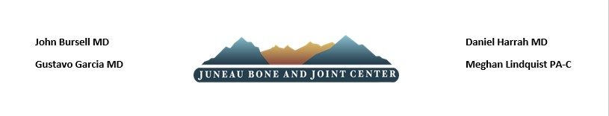

MRI NO-SHOW/ CANCELLATION POLICY
ALL MRI PATIENTS MUST REVIEW THIS POLICY & SIGN BELOW

- If you are taking medication for claustrophobia for your MRI scan, be aware that you will be unable to drive for 12 hours after taking it. This will require you to arrange for a ride prior to coming in for the appointment. If you do not have reliable transportation, your MRI scan may be rescheduled to a future date. This also may result in a "No Show/Cancellation fee"
- MRI cancellations need to be done 24hrs in advance. Failure to do so, patient can incur a $50 fee applied to your account.
- Patients can be charged a $50 fee if they do not show up to their scheduled MRI appointment.
NOTE: This fee must be paid in full in order to reschedule the MRI
- Patients are required to show up 10 minutes PRIOR to their appointment. Failure to do so can result in cancellation of their MRI and $50 fee. Showing up late will be considered a no-show.
If you are running late, please call the MRI scheduler @ 907-364-2675
- ALL jewelry must be removed PRIOR to checking for MRI.
- If a patient misses (2) scheduled MRI appointment, the patient will be scheduled on-call basis. No pre-scheduled MRI appointments will be allowed. The patient will be required to call same day, and if there is availability patient will be considered for opening.

***All situations will be assessed on a case-by-case basis. ***

By Signing below, I acknowledge the terms listed above.

Patient Name: __________________________________ Date of Birth: ______________
Patient Signature: _______________________________
(Or)
Guardian Signature: ______________________________ Date: ____________________

